MEMORANDUM
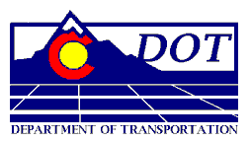
DEPARTMENT OF TRANSPORTATION
Division of Transit and Rail
4201 East Arkansas Avenue, Room 280
Denver, CO 80222
Phone: 303-757-9646
Fax: 303-757-9656

TO: Transit & Rail Advisory Committee (TRAC)

FROM: Mark Imhoff

DATE: January 11, 2013

RE: TRAC Introductory/Orientation Background Documentation

This memo lists the available and relevant Historical documentation for your reference:

- DTR enabling legislation/SB 09-094
- FASTER legislation/SB 09-108
- Your CDOT Dollar web site
- Transportation Matters UTube
- CDOT Organization Chart
- DTR Organization Chart
- DTR web site
- FRA Website
- FTA Website
- TRAC web site
- TRAC Vision/Vision Values (This needs to be created!!!)
- State Freight and Passenger Rail Plan
- Establishing Framework for Transit and Rail Performance Measures (December 2012)
- CDOT Transit Guiding Principles (October 2012???)
- Interregional Connectivity Study web site
- I-70 Mountain Corridor Advanced Guideway System (AGS) Feasibility Study web site
- Regional-Commuter Bus White Paper (December 2012)
- 2013 TRAC Roster/Sub-Committee assignments
- TRAC Introductory Power Point (January 11, 2013)
- 2013 Legislative Session Overview

